E2026/90642
 | 
Attachment D – Public Submissions Review
NORTHERN REGIONAL PLANNING PANEL

PANEL REFERENCE & DA NUMBER | PPSNTH-427 – BYRON – 10.2025.212.1
PROPOSAL | Amended DA - Demolition of public toilets (heritage item), car park and tree removal. Affordable housing mixed use development comprising shop top housing (28 apartments above ground level), one ground floor commercial premises and ground floor boarding house, carparking, landscaping and associated services
ADDRESS | Lots 6, 7 & 8, Section 3 DP 2772 – 57 Station Street Mullumbimby

The proposal was notified in accordance with the Council’s Community Participation Plan on two occasions. The original DA was notified from 3/7/2025 to 3/8/2025. The Amended DA was notified from 22/6/2026 to 16/8/2026.

An overview of submission numbers is provided in Table 1. An assessment of the public submissions is provide in Table 2.
Note. Multiple submissions by same person counted as a single submission

Table 1 – Public Submission Numbers
Exhibition | Template submissions | Total submissions | Total objections | Total support | Multiple submissions by one person/group
Original DA | 404 | 724 | 719 | 5 | 58
Amended DA | 883 | 1,768 | 1,767 | 1 | 31

Table 2 - Public Submissions Assessment
Issue | Assessment Comments
Infrastructure and Servicing
Sewer main  Sewer main runs adjacent to and approximately parallel to the southern site boundary. | The original version of the DA was lodged on 25/06/2026. A Council sewer main runs parallel to, and approximately 1.5m from, the southern boundary. The original proposal was generally setback 3.0 from the southern boundary, with one element of the building with zero southern setback. An amended DA was submitted on 16/06/2026. Council requested amended plans to, among other things, relocate the building further to the north for compliance with Byron Shire Policy – Building in the Vicinity of Underground Infrastructure 2025. The amended proposal now has a general southern setback of 3.69m and the zero-setback southern element of the building was eliminated.  The DA was supported with the following relevant documentation:  - Civil Engineering Plans prepared by JHA Engineers;  - Survey of Sewer prepared by Bennett & Bennett;  - Footing Design Statement regarding Council Policy – Building in the Vicinity of Underground Infrastructure prepared by Northrop Engineers.  The issue is resolved with the amended proposal. Can be managed with conditions of consent.
Flooding and Stormwater | The subject allotment is in the flood planning area. All habitable rooms are above the flood planning level. The DA was supported by the following engineering documentation:  - MUSIC and TUFLOW Stormwater modelling;  - Stormwater Quality Improvement Device (SQID) operations and maintenance report, prepared by JHA Engineers;  - Flood Impact Assessment prepared by JHA Engineers.  The flood Impact Assessment prepared by JHA Engineers confirms that:  - The site is subject to shallow, slow moving overland flows along Station Street and McGoughans Lane during the 1% AEP flood event.  - The proposed development is not impacted by overland flows during the 1% AEP event.  - The proposed development will not result in any adverse impacts on 1% AEP flood behaviour or increase flood risk to surrounding properties.  Council’s Development Engineer is satisfied with the conclusions of the additional Flood Impact Assessment; and Stormwater information, prepared by JHA Consulting Engineers. The assessment adopts Council's flood model, incorporates site-specific survey information and demonstrates that the proposed development is unlikely to cause significant changes to flood behaviour or flood levels in surrounding roads and properties. The assessment indicates that changes in flood levels are generally less than 10 mm during the critical 1% AEP event and are therefore considered negligible. Appropriate conditions recommended for stormwater and flooding.  The issue is resolved with the provision of additional information. Can be managed with conditions of consent.
Fences/gates on overland flow path | If the proposal is approved a condition of consent would require minimum 60% permeability for either gates or fences within an overland flow path.
Flood Emergency Response Plan | If the proposal is approved a condition of consent would require a site specific Flood Emergency Response Plan.
Infrastructure capacity | Council’s Water and Sewer Engineers have confirmed that services can be provided to the site. Developer Servicing charges apply.  Council’s Developer Contributions Officer has confirmed that developer contributions will apply. Developer Contributions provide funding for the provision of services and infrastructure. Officers comments follow:  Mixed used development. Higher of Section 7.11 and Section 7.12 developer contributions apply. In this case, S7.11 is higher.  28 dwellings in total comprised of 12 x studios, 12 x one bedrooms, 4 x two bedroom units.  For the 24 dwellings that meet SEPP criteria for affordable housing contributions will be deferred whilst ever this criteria is met. The remaining four apartments will be subject to s7.11 contributions.  Council’s Development Engineer has confirmed that suitable arrangements can be made for stormwater drainage, vehicular access and car parking, subject to conditions of consent.  Adequate infrastructure and services and be provided to the site subject to conditions of consent.
Powerlines | The proposal was referred to Essential Energy in accordance with the previous requirement of SEPP (Transport and Infrastructure) 2021 (now SEPP (Planning Systems) 2021). Essential Energy had no comments to make in relation to potential safety risks arising from the proposed development. Subject to the relocation / replacement of overhead conductors on the eastern and western sides of the proposed development as outlined in the Powerlines Concept Plan submitted with the amended DA. General requirements can be listed in the Notes section of a development consent.  The proposal involves various powerline works associated with the site (details provided with DA) including, but not limited to, undergrounding LV lines on the eastern frontage of the site; remove existing overhead LV conductor that crosses Station Street in front of the site and relocate further north with overhead multiple insulated conductors (LVABC) and relace bare overhead conductors on western side (McGoughans Lane) with multiple insulated overhead conductors (LVABC). The proponent has engaged an Accredited Service Provider Level 3 (ASP 3) (JHA Consulting Engineers) to design and work with Essential Energy to undertake the works that can be done as development without consent under SEPP (Transport and Infrastructure) 2021.  The issue is resolved with the provision of additional information. Can be managed with conditions of consent.
Waste management | The DA was supported with the following relevant documentation:  - Waste Management Plan prepared by MRA Consulting Group.  Proposed waste collection using a private contractor from McGoughans Lane. There is a loading bay within the property boundary that will accommodate a waste collection vehicle (SRV). Bin areas are located in a fenced area within the car park.  There is currently no Council bin collection in McGoughans Lane which is a 6m wide road reserve. Preliminary discussion with Council Waste Officer indicates that waste collection in McGoughans Lane is feasible. Waste collection in McGoughans Lane would likely benefit most landholders/occupants in the lane.  Waste management addressed with conditions of consent that requires adherence with the approved Waste Management Plan.
Rear access to restaurants in Burringbar Street | The amended DA was lodged on 16/06/2026 and one of the modifications included setting the building back 3.6m from the southern boundary in order to create an easement over the sewer main that generally runs parallel to, and 1.5m to the north of, the southern boundary. Council’s Legal Counsel has been in discussions with the owner of the land within which the businesses are located (Lot 3 Section 3 DP 2772). It is possible to locate an access easement within the sewer easement that would benefit Lot 3 Sec 3 DP 2772, however this will be a matter for the landowner to pursue.  The issue can be resolved if the landowner of Lot 3 Section 3 DP 2772 pursues the matter.  It is noted alternative easements could also be pursued with negotiation through the other adjacent properties to the west which have access from McGoughans Lane or with the properties from the east which have access from Station Street. This would be up to the landowner of Lot 3 Section 3 DP 2772 to pursue with those land owners.
EV parking spaces inadequate for future demand. | Four EV parking spaces are proposed, and the remaining spaces will be EV ready. The National Construction Code requires new class 2 buildings to feature dedicated electrical distribution boards and space/capacity in the car park to support future EV chargers for parking spaces.
Commercial parking and security gates | Can be managed with conditions of consent.
Traffic, parking and access
Loss of public car park | The demolition component of the proposed development involves demolition of a heritage listed public toilet building, public carpark (43 spaces) and associated services and the removal of 32 native and exotic trees.  The importance of appropriate and well-located car parking is a high priority for Byron Shire Council and the community it serves. This is evidenced in Community Strategic Plan (CSP) 2035 Section 5.2; and the Delivery Program (DP) 2025-29 Section 5.2. Byron Shire Council Operation Plan (OP) 2026-27 includes provision for alternative arrangements for parking in the Mullumbimby Rail Corridor. Below is an extract from the OP.  The Byron Shire Local Infrastructure Contributions Plan 2026 came into effect on 1 July 2026. Mullumbimby railway land car parking is a line item in the plan (Appendix E – Works Map, Table D.5: Traffic and Transport, Item TT5). Council has recently prepared concept plans for Mullumbimby car parking (Refer to concept plans below and Section 5 of the assessment report for detail). Concept car parking includes:  - Land adjacent to the north of Woolworths proposed to provide 128 car parking spaces (including 2 accessible spaces) with access from Station Street; and  - Land on the western side of Prince Street, directly opposite Northern Rivers Autocare (Carsburgs) proposed to provide 27 car parking spaces (including 2 accessible spaces).  Proposed car parks – Station Street & Prince Street Mullumbimby  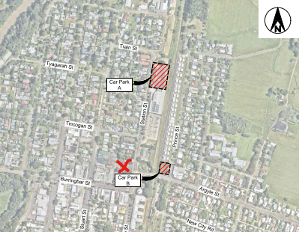  Station Street car park  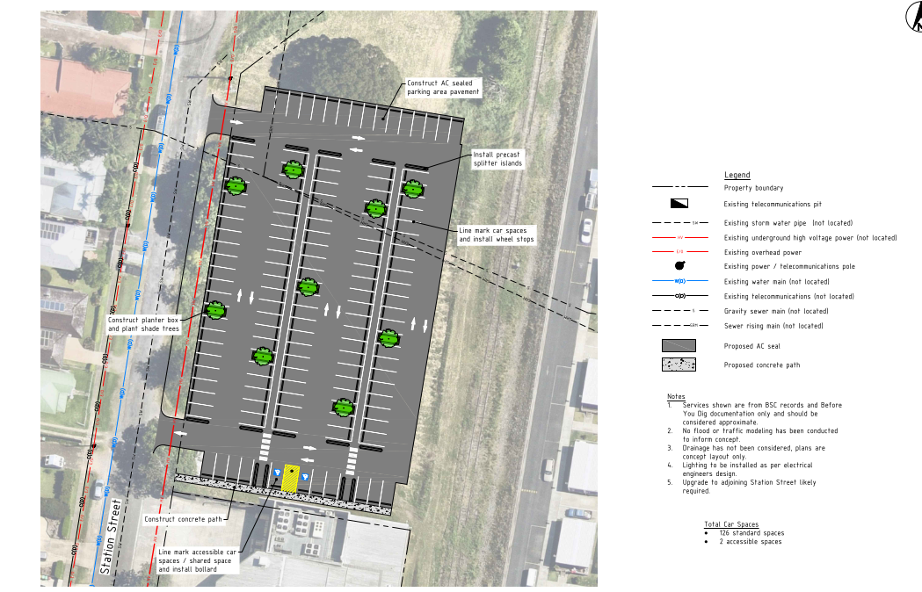  Prince Street car park  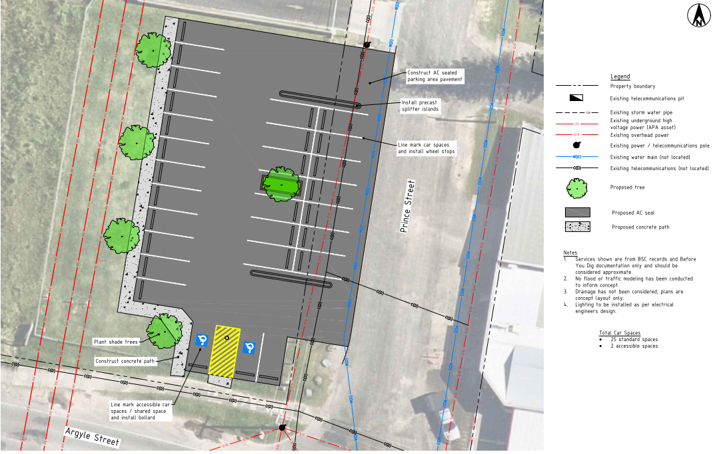
  Operational Plan Activity | Description | Due
  5.2.4.4 | Review and provide a detailed study report of parking in Mullumbimby. The completion measure is "Strategy progressed." | 30 June 2027
  5.2.4.5 | Mullumbimby Rail Corridor Parking – finalise concept layout designs. | 30 June 2027
Construction and operational traffic | The DA was supported by the following relevant documentation:  - Traffic Impact Assessment, prepared by Bitzios Consulting – Traffic Engineering & Traffic Planning, dated 21 May 2025;  - Traffic Impact Assessment – Additional Information, prepared by Bitzios Consulting – Traffic Engineering & Traffic Planning, dated 1 June 2026.  The traffic assessment utilised intersection traffic surveys, automatic tube counts (ATC) and Signalling, Integrated Design and Research (SIDRA – micro-analytic traffic evaluation software). ATC was used at McGoughans Lane (80m north of Burringbar Street); Tincogan Street (just east of McGoughans Lane); and Burringbar Street (just east of McGoughans Lane). SIDRA analyses were undertaken for McGoughans Lane / Tingogan Street intersection and McGoughans Lane / Burringbar Street intersection.  Council’s Development Engineer reviewed the traffic reporting and concluded that operational traffic would generate a low impact to the existing road network.  The matter of construction traffic can be dealt with as a condition of consent prior to the issue of a Crown Certificate.
On-site car parking – SEPP (Housing) 2021 concessions | SEPP (Housing) 2021 does provide car parking concessions for affordable housing compared with the requirements of Byron DCP 2014. State Environmental Planning Policies are Statewide in their application, regardless of whether the location is regional or metropolitan and regardless of the availability of public transport. The table below provides a comparison of affordable housing car parking requirements under the SEPP and non-affordable housing under the DCP.  Car parking comparison for proposed development  The SEPP prevails over the requirements of other EPIs in accordance with clause 8 of the policy.
  Land use | SEPP (Housing) 2021 | Byron DCP 2012
  4 x boarding house rooms | 0.5 x 4 = 2 | 0.5 x 4 = 2
  28 x shop top housing apartments (24 affordable) | Affordable  22 x 1 bed/studio – 22 x 0.4 = 8.8  2 x 2 bed – 2 x 0.5 = 1.0  Non-affordable  2 x 1 bed – 2 x 0.5 = 1  2 x 2 bed – 2 x 1 = 2 | 28 x 1 = 28  Visitor 28 x 0.25 = 7
  77.4m² shop | DCP applies = 4 | 4
  Total | 18.8 | 41
  Proposed – 19 spaces
Loading bay | Council’s Development Engineer is satisfied that the loading bay is satisfactory for a small rigid vehicle (SRV) and this is all that is required under the Byron DCP 2014. Larger medium rigid vehicles (MRV) or a heavy rigid vehicle (HRV) such as a garbage truck could still use the loading bay with some of the vehicle being outside of the property boundary. While Council currently doesn’t provide bin collection in McGoughans Lane (6m wide lane) there are numerous other 6m rear laneways that do have a bin collection service in the Shire and it is likely that this will be extended to McGoughans Lane. Council bin trucks servicing 6m wide rear lane stop and start in the laneway without utilising loading bays.
Public access through the site | Currently pedestrian access is enabled through 57 Station Street. The proposed development does not include a public walkway from McGoughans Lane to Station Street. It is considered reasonable that pedestrians can travel east west along Burringbar Street and arrive at their destination without a significant increase in distance.
Built form, heritage and amenity
Loss of heritage listed toilet | Two issues are considered below, being, the loss of a locally heritage listed building; and the loss of public toilets.  Heritage  A Heritage listed public toilet (LEP Schedule 5) designed by Byron Bay based architect Christine Vadaz, particularly active in the profession from the 1980’s onward, is located within the subject site.  After consideration of the Statement of Heritage Impact prepared by Everick Heritage; and the comments from Council’s Heritage Advisor; an appropriate strategy to deal with the proposed demolition is to condition the consent requiring: a) an archival report of the heritage item; and b) the preservation of the roof for reuse in a future small scale civic building such as a gazabo or the like, preferably in Mullumbimby. Council’s asset management staff have been informed of the circumstances and short-term storage is possible while an appropriate reuse is decided upon.  The issue is can be resolved with conditions of consent.  Loss of public toilets  Public toilets available in Mullumbimby town centre include:  - Mullumbimby Tennis Club Recreation Ground – toilets are located within the fenced enclosure and are part of the tennis club. Additionally, public toilets are located outside of the fenced enclosure.  - Mullumbimby Civic Centre Memorial Hall – toilets are available within the building for public use. However, opening times vary depending on a specific concert, market o=r function booked.  - 57 Station Street within the public car park (proposed for demolition) –  - Byron Shire Council Administration building – open within normal office hours  The Byron Shire Local Infrastructure Contributions Plan 2026 came into effect on 1 July 2026. A new Mullumbimby amenities block, including hot showers and solar, is a line item in the draft plan (Appendix E – Works Map, Table D.3: Community Facilities, Item CF2). At the time of writing, Council’s Business Analyst / Contributions Officer, from Council’s Infrastructure Services Directorate, indicated that a site for the amenities block was yet to be determined, however, it is planned for an “in town” location.
Height, bulk and scale | The DA was supported with the following relevant documentation:  - Statement of Environmental Effects, prepared by Wilson Planning, dated June 2026;  - Design Verification Statement, prepared by Hill Thalis Architecture, dated 28 March 2025;  - Housing SEPP Design Principles and Apartment Design Guide Parts 3 & 4 Report, dated 28 March 2025.  Various meetings and correspondence with the applicant and their team have occurred subsequent to the initial date of lodgement, being 25/6/2025. The applicant was requested to amend the plans to, inter alia, relocate the building off the sewer main and to reduce the bulk and scale of the building from the Station Street façade. An amended DA was lodged on 16/6/2026. The amended DA satisfied various requests for additional information and relocation of the building further to the north away from the sewer main. However, the Station Street façade was generally not modified.  A further request to amend the plans to reduce the Station Street façade bulk and scale was issued to the applicant on 15/7/26; and followed up with a meeting on 25/9/2026; and amended plans were submitted to Council on 29/9/2026. The amended plans have generally addressed the Station Street bulk and scale matter with: the elimination of part of the second level verandah; increased front setback; and footpath and landscaping works in Station Street. Additionally, the use of F/C cladding or similar with a soft colour palate, via a recommended condition of consent, will also be used to clad the building in association with the proposed galvanised iron and masonry. These modifications are more compatible with the aesthetic character of the Mullumbimby Heritage Conservation Area.
Solar access | The DA was supported by the following relevant documentation:  - Shadow Analysis – Winter Solstice, prepared by Hill Thalis Architects dated 28/5/26  - Statement of Environmental Effects, prepared by Wilson Planning, dated June 2026  Refer to Aeriel View below of 5 adjoining southern commercial properties, all within Zone E1 Local Centre.  Aerial view of adjoining southern commercial properties  Note. Number 72 (centre allotment) is currently used as alfresco dining for two restaurants  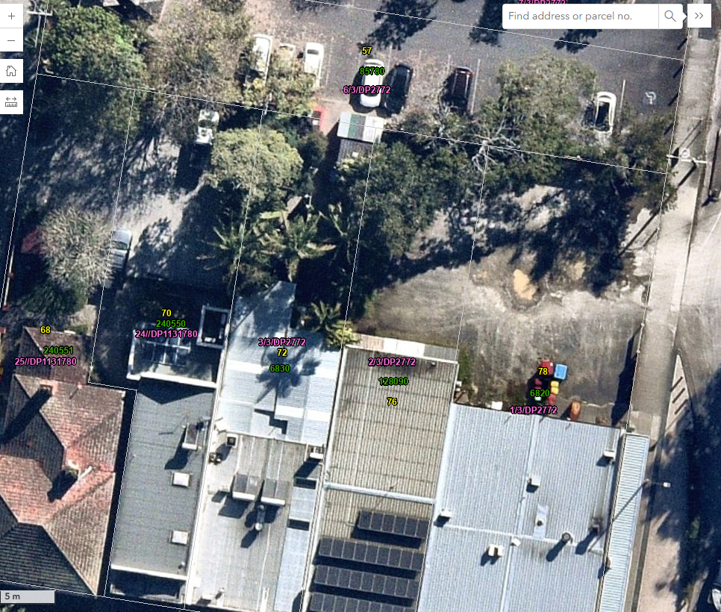  Refer to Shadow Analysis – Winter Solstice below.  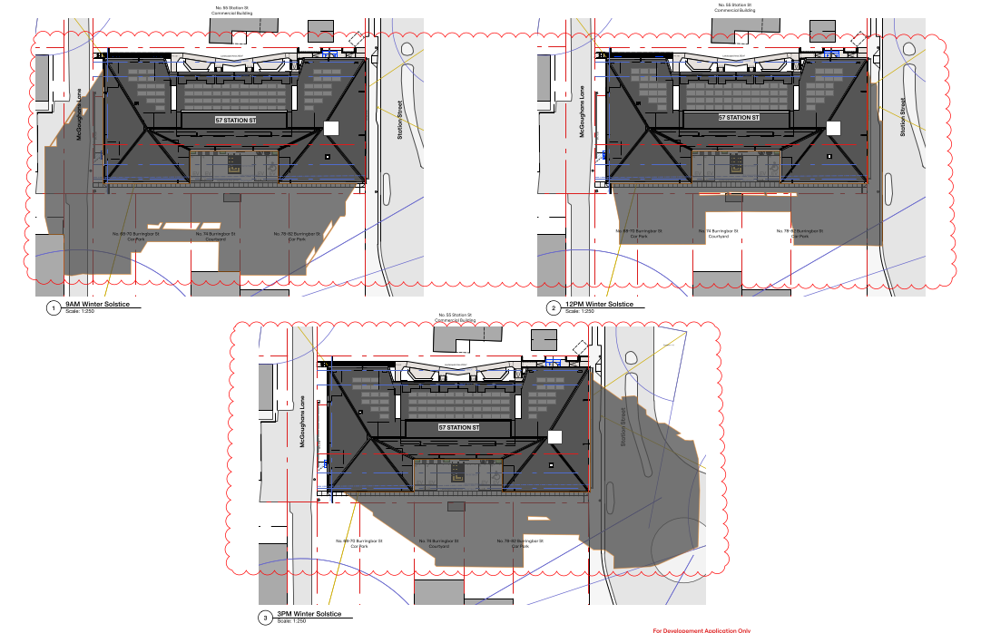  The Apartment Design Guide Section 3B-2 applies – Overshadowing of neighbouring properties is minimised mid-winter. Byron DCP D1.2.1 – Building Height Plane does not apply to shop top housing (refer to Prescriptive Measure 1 of that section of the DCP).  Overshadowing of the adjacent southern properties is minimised during mid-winter.  - The amended DA relocated the entire building 0.7m further from the southern boundary. The southern setback is 3.6m with the central part of the building setback approximately 8m.  - The adjacent southern allotments are within an employment zone where consideration of solar access is not as significant as it is in a residential zone, considering that these sites could eventually be redeveloped and may use zero lot line setback.  - The proposed 3.6m-8m setback from the southern boundary in Zone E1 Local Centre is very generous and serves to minimise overshadowing on the adjacent commercial premises. The northern portion of No. 68, 70, 76 & 78 are all used for private car parking and not for outdoor open space. However, significant portions of the car parking spaces will maintain unimpeded solar access. Additional shade in these locations may even be beneficial for car parking. No 72 is occupied by two restaurants where the vegetated northern portion of the lot is used for alfresco dining. In this location, the adjoining proposed northern building is setback approximately 8m. The alfresco dining area would receive more than 3 hours solar access during the winter solstice. Moreover, most of the solar access is achieved between 10am to 1.30pm, likely peak lunch times for diners.  The assessment of solar access for adjoining southern allotments is considered satisfactory and does not require amendment to the design.
View loss | View loss from public open spaces, street network and walkways would generally be unimpeded by the proposed development. While there may be some locations that a pedestrian could position themselves to experience view loss of Mount Chincogan; a short walk to another location would restore the vista. Narrow corridor view loss from public open spaces is not as significant as it may be from, say, a loungeroom of a dwelling.  The mid distance view to Mount Chincogan and Mount Jerusalem National Park will still form a predominant back drop to the entrance to the town centre when approaching from the east, with or without the proposed development.  Byron DCP Chapter C3 and View Sharing Principles do not apply in this instance. View sharing principles established in Tenacity Consulting v Warringah Council [2004] NSWLEC are not applicable.
Visual amenity due to absence of communal drying areas | Drying areas are available for all apartments without the continual need for clothes dryers. Photovoltaic panels are proposed on the large northern facing hipped roof, thus ensuring the sustainable use of electrical appliances.
Landscaping | The site is currently an asphalt car park with some perimeter trees and shrubs. The proposal substantially increases the amount of deep soil planting, comprising 30% of the site, exceeding the 7% required by the ADG. Landscaping is proposed within the southern, western and northern setbacks and the eastern road reserve. Landscape Design Intent, prepared by Ivy May Landscape Architecture; and Arborist’s Report, prepared by Catherine Russo accompanied the DA. Landscaped area, design and species selection in accordance with SEPP (Housing) 2021 and DCP requirements. Council’s Consulting Ecologist is satisfied with landscaping species selection. Approximately 4 trees on site proposed for retention including Syzygium moorei (Coolamon) and Callistemon spp (Bottlebrush).  Communal landscaped ground floor area totals 507.3m². The proposed landscaping will enhance residential amenity; and provide privacy, shelter, habitat and shade. It will also enhance the street appeal of the building.  Inappropriate species will not be permitted over the sewer main. Landscaping can be managed with conditions of consent.
SEPP (Housing) 2021 Building height, ceiling height & floor areas | The architectural plan set (elevations and sections) show compliance with SEPP (Housing) 2021 height limit of 11.7m; ceiling height of 2.7m and minimum floor areas.
Governance and process
Consultation and transparency | Pre-lodgement consultation by proponent  The proposed development is classified as Community Significant Development in accordance with the Byron Shire Council Community Participation Plan and engagement with the community was required by the proponent before the lodgement of the DA. Pre-lodgement engagement undertaken by Landcom and a Community Engagement Report was submitted with the original DA. Pre-lodgement community engagement is summarised below:  - An online engagement platform that included FAQ’s, illustrations, key information and an ideas board;  - Feedback surveys for residents, community organisations and business providers;  - Two community drop-in sessions held on:  Monday 2/12/2024 from 5pm to 7pm  Tuesday 3/12/2024 from 9.30am to 11am  - Targeted meetings were held with:  Mullumbimby Business Chamber  Mullumbimby Residents Association  Issues raised during pre-lodgement engagement:  - Site location – why there?  - Loss of public parking  - Loss of public toilet  - Question the need for affordable housing  - Traffic and parking impacts  - Construction impacts  - Flood risk  - Design of the development  - Impact of the development on the character of the town centre  Public Exhibition No. 1  The original DA was lodged on 25/6/2025 and was publicly exhibited from 3/7/2025 to 31/8/2025.  Public Exhibition No. 2  The amended DA was lodged on 16/6/2026 and was publicly exhibited from 22/6/2026 to 16/8/2026.  Public consultation for the proposed development was undertaken in accordance with the Byron Shire Council Community Participation Plan.
Land sale price withheld | Pursuant to Section 4.15 of the EP& A Act 1979 the sale price of the land is not a matter for consideration for the assessment of a development application.
Unconfirmed financial viability | Pursuant to Section 4.15 of the EP& A Act 1979 the financial viability of a project is not a matter for consideration for the assessment of a development application.
Alternative sites | Assessment of alternative sites  Pursuant to Section 4.15 of the EP& A Act 1979 the investigation or assessment of alternative sites is not a matter for consideration for the assessment of a development application.
Land Classification | The subject land at 57 Station Street is classified as operational land. Pursuant to Clause 45(1) of the Local Government Act 1993, Operational land is the only land classification that enables the sale of Council owned land.
Community housing provider uncertainty | SEPP (Housing) 2021, Part 2 Development of affordable housing, Division 1 In-fill affordable housing, Clause 21 follows:  21 Must be used for affordable housing for at least 15 years  (1) Development consent must not be granted to development under this division unless the consent authority is satisfied that for a period of at least 15 years commencing on the day an occupation certificate is issued for the development—  (a) the development will include the affordable housing component required for the development under section 16, 17 or 18, and  (b) the affordable housing component will be managed by a registered community housing provider.  (2) This section does not apply to development carried out by or on behalf of the Aboriginal Housing Office or the Land and Housing Corporation.  A development application can be approved without a fully executed management contract in hand, however, evidence of an agreement with a registered community housing provider and relevant title instruments (such as Section 88E instrument) must be satisfied prior to the issue of an Occupation Certificate; or in the case of a Crown DA, prior to occupation of the building.  The applicant stated, “A community housing provider will be chosen once the latest round of Housing Affordability Fund funding has been secured for the project”.
Affordable Housing resolution 26-104 | Council resolution 26-104 is provided below  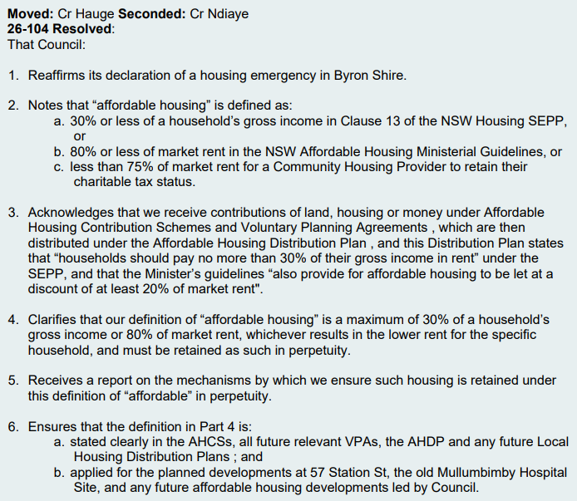  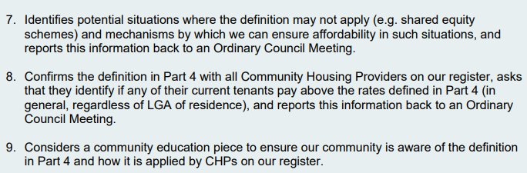  SEPP (Housing) 2021 provides controls relating to the rental caps and time period within which the development remains ‘affordable housing’. Byron Shire Council has the opportunity to specify further requirements within a contract of sale for the subject land. Refer to Council resolution24-252 below:  24-252 Resolved that Council:  1. Notes the update to Resolution 23-300 (item 2) on the progress of the request for proposal (RFP) process outlined in this report.  2. Sells the land identified as lots 6, 7 and 8 in DP 2772 (together known as 57 Station Street, Mullumbimby (the Land) to the project’s preferred community housing provider.  3. Proceeds with Resolution part two, subject to Council entering a contract for sale for the Land on terms satisfactory to it, including a covenant registered on the title that:  a) the land is only used for the purpose of affordable housing; and  b) requires the land be transferred back to Council if the land ceases to be used for the purpose of affordable housing.
Housing above Council owned car parks. Resolution 20-069 | Council resolution 20-069 is provided below.  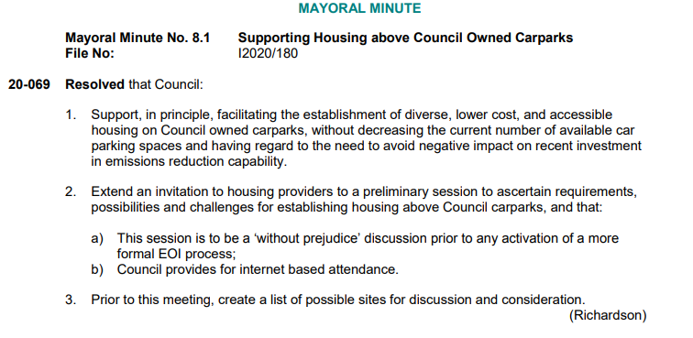  Refer to assessment comments under “loss of public car park” elsewhere in this table. While the retention of 57 Station Street car parking is not proposed as part of the development application, alternative arrangements are in place in accordance with the 2026/27 Operational Plan and the Byron Shire Local Infrastructure Contributions Plan 2026.
Crown development  Request that assessment report clearly identify conditions not accepted by the Landcom. | The development application is Crown development and will be subject to Division 4.6 – Crown development, of the EP&A Act 1979.  Request noted. The Government Information (Public Access) Act 2009 provides for the access of Government information in NSW.
Crown Development and no Construction Certificate – concern vibration impacts will not be assessed. | Crown Development does not require a Construction Certificate, however, Crown Certification is required that assesses compliance with the National Construction Code in accordance with Section 6.28 of the EP&A Act 1979.  Condition of consent - A Construction Site Management Plan (CSMP) will be required prior to Crown Certification. The CSMP, among other things, is to provide a management regime for dust, noise and vibration.
Social and economic impacts
Business disruption | Several reports were submitted with the DA relating to construction phase operations including:  - Noise Impact Assessment Report, prepared by JHA Services, dated 18/3/2025;  - Geotechnical Investigation Report, prepared by ASCT, dated 25/11/2024;  - Traffic Impact Assessment, prepared by Bitzios Consulting, dated 21/5/2025;  - Waste Management Plan, prepared by MRA Consulting Group, dated 29/6/2026;  - Additional Traffic Assessment Information, prepared by Bitzios Consulting, dated 1/6/2026  Council’s Environmental Officer and Development Engineer have assessed the proposal and reports related to their disciplines and they are satisfied that negative impacts on surrounding existing development can be mitigated with the recommendation of appropriate conditions of consent.
Urgent need for affordable housing. | The provision of affordable housing is given a high priority in Byron Shire Council’s plans and strategies, including but not limited to the Byron Shire Community Strategic Plan 2035; Byron Shire Council Delivery Program 2025-29; Byron Shire Council Affordable Housing Contributions Policy; Byron LEP 2014 Part 6, Division 2 Affordable Housing provisions; Byron Shire Council Residential Strategy 2041; Short Term Rental Accommodation 60 day limits; and Homes NSW and Byron Shire Council MOU.
Affordable housing | The proposed development includes the following affordable housing under SEPP (Housing) 2021  - Four x boarding house rooms – pursuant to clause 26 of the Housing SEPP a boarding house is affordable housing in perpetuity.  - Twenty four of the proposed twenty eight shop top housing apartments are proposed for affordable housing. Pursuant to clause 21 of the Housing SEPP these dwellings must be affordable housing for a least 15 years.
Social Impact | The DA was accompanied by a Social Impact Assessment (SIA), prepared by Dr Rigmor Berg of BB Professional Services, dated March 2025.  The SIA considers the Mullumbimby Master Plan, the local population profile, housing availability and demand of the community, and the results of consultation with the community. The SIA states that there is a 'clear and urgent need for more affordable rental housing for key workers in Mullumbimby. Services and businesses cannot function if they cannot attract and retain essential staff due to lack of suitable housing'.  The SIA notes that the location of this site is close to the CBD, where many key worker jobs are located, as well as to the shops and services that will be needed by those workers. It further notes that public transport is limited, but there is a bus stop nearby for services that link Mullumbimby to Ocean Shores, Byron Bay, Suffolk Park, Lennox Head and Ballina via two routes.  Pre-lodgement community consultation used in preparation for the SIA identified several issues of community concern. It is worth noting that all the issues raised in the SIA were again recorded in the public submissions received during the two periods of public exhibition. All the issues have been addressed either with: the submission of additional information and amended plans; the recommendation of appropriate conditions of consent; or other development assessment comments provided in this table or in section 5 of the assessment report.
Economic impact | The construction of the proposed development will provide short term employment opportunities in the locality and support the local building and development industries. This will have direct monetary input to the local economy, and the increased number of residents in the locality will provide ongoing economic input through daily activities.  The increase in housing within the area will directly influence and enhance business and employment opportunities within the town centre and capitalise on the site's very close walking distance to local employment and public transport.  There are no anticipated adverse economic impacts because of the proposed development.
Public Interest
Not in the public interest to lose a public toilet when a replacement toilet will cost between $0.5M to $1M | This is not a matter for consideration in the assessment of this development application.
Not in the public interest transfer ownership of a public car park for a nominal sale (selling for $1 instead of market value) | This is not a matter for consideration in the assessment of this development application.

